Future Finger Technologies

-

Introduction
Digital marketing gives businesses of any size access to the mass market at an aordable price and allows truly personalized marketing. Special benefits of digital marketing include:

Global reach Lower cost
Tractable, measurable results Personalization
Improved conversion rates
Together, all of these aspects of digital marketing have the potential to add up to more sales.

About us
Since we began in Nov 2015 we have continued to learn and re ne our process as the industry evolves. Along the way we developed advanced quality control and reporting, internal and external continuing education for our cutting edge content development and marketing team.

With over 14dedicated employees, Future Finger Technologies Pvt. Ltd has amongst the largest pool of Internet marketing professionals you will at an agency Future Finger Technologies Pvt. Ltd is led by an experienced management team, which provides strategic direction and support for the company. Our management team's hands-on approach has led to Future Finger Technologies Pvt. Ltd becoming a multiple recipient of numerous “Best Places to Work" .

Our Services

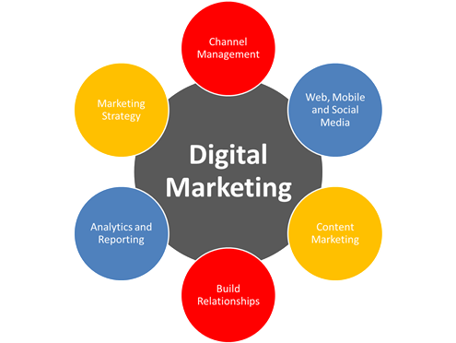

Description of services
The following services will be provided as part of the program:

Social Media Marketing

Search Engine Optimization

Pay-Per-Click Advertising (PPC)

Email Marketing

Content Marketing

Affiliate Marketing

Display Advertising

Online PR

Competitive Analysis

Web traffic

Brand perception

Social media prescience

SEO audit

Competitor analysis

Our Approach

Lead generation

Social media Strategy

SEO

Content marketing

Testimonials

Improving Your Business Helps Us Improve Ours

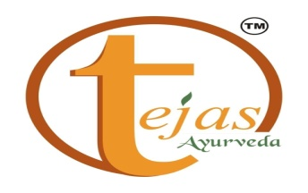
Success Stories:

Pramod Aggarwal
CEO/Founder
www.tejasayurveda.in
Future Finger Technologies has been very responsive and available to answer my questions. They proposed aggressive yet realistic goals Compare Ayurvedic Products an honest outline of expected measurable results. To date, they've been right on target and have delivered what they said they would. From website design and SEO to PPC optimization, these guys are the real deal and true professionals.

Item | Price
Digital Marketing services contract | 10 % Of Total Budget Or 5000 Whichever is higher
Social Media Marketing | 10 % Of Total Budget Or 5000 Whichever is higher
Search Engine Optimization | 1000 per Keyword
Pay-Per-Click Advertising (PPC) | 10 % Of Total Budget Or 5000 Whichever is higher
Email Marketing | 2500 Per lacs

Terms and conditions

The Retainer amount is subject to increment if the Scope of Work or Duration increases beyond the deliverables or expectancy.
Client shall notify the in writing one(1)month in advance whenever they would like to discontinue the engagement and vice versa.
IncaseofterminationwillpaytheamountinvoicedtilltheterminationdatetoAnynoticegivenbyoneparty to the other pursuant to this Contract shall be sent to the other party in writing or by fax and confirmed in writing to the other party's specified address .The same has to be acknowledged by the receive in writing. In cases of dispute, claim & legal action arising out of the contract, the parties shall be subject to the jurisdiction of courts in [Delhi]

